Part 1 :

Code :

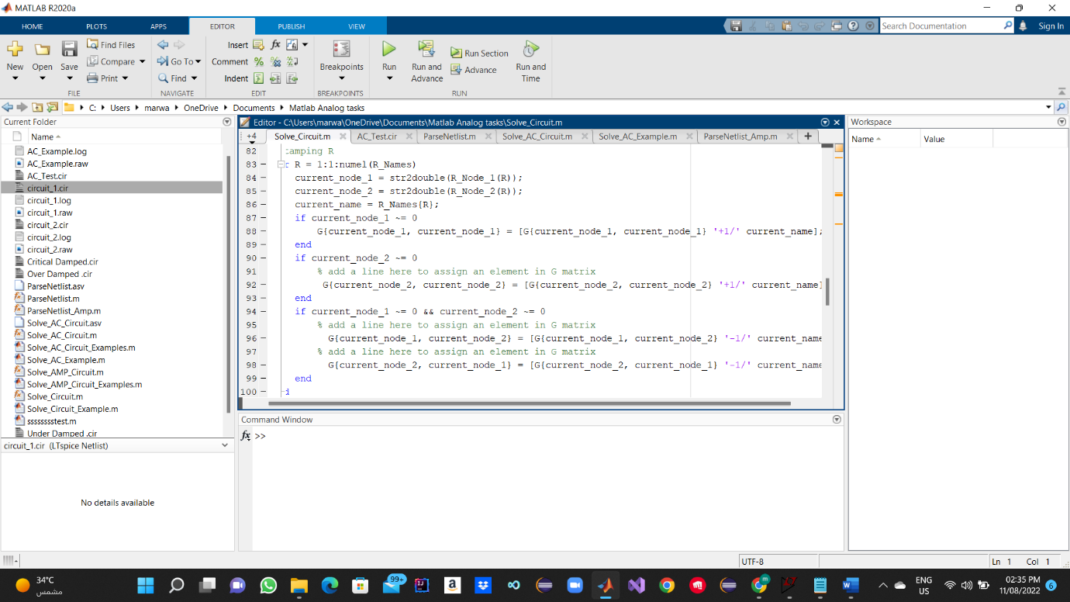

Simulation Results

And Solve Example is completed :

Table Compare:

|  |  |
| --- | --- |
| Matlab | Ltspice |
| the first netlist:  V_1 = 30.000000  V_2 = 16.956522  I_Vb = -0.260870  the second netlist:  V_1 = 40.000000  V_2 = 14.634146  V_3 = 32.195122  V_4 = 112.195122  I_Vb = -1.268293 | the first netlist:  V(1): 30 voltage  V(2): 16.9565 voltage  I(Is):  2 device_current  I(R3): 1.69565 device_current  I(R2): 0.565217 device_current  I(R1): 0.26087 device_current  I(Vb): -0.26087 device_current  the second netlist:  **V**(1): 40 voltage  V(2): 14.6341 voltage  V(3): 32.1951 voltage  V(4): 112.195 voltage  I(Is): 1 device_current  I(R6): 0.804878 device_current  I(R4): 1.46341 device_current  I(R3): -1 device_current  I(R2): -0.195122 device_current  I(R1): 1.26829 device_current  I(Vb): -1.26829 device_current |

Ltspice Find The value of the Current in each branch while Its Not Supported in my code And The results of The voltage Nodes My Code have higher precision.

Part 2:

Created the script for solving Ac.

Created the script for solving Ac Example.

My Simulator Results:

Over Damped RLC:

Critical Damped RLC:

Under Damped RLC With Peaking :

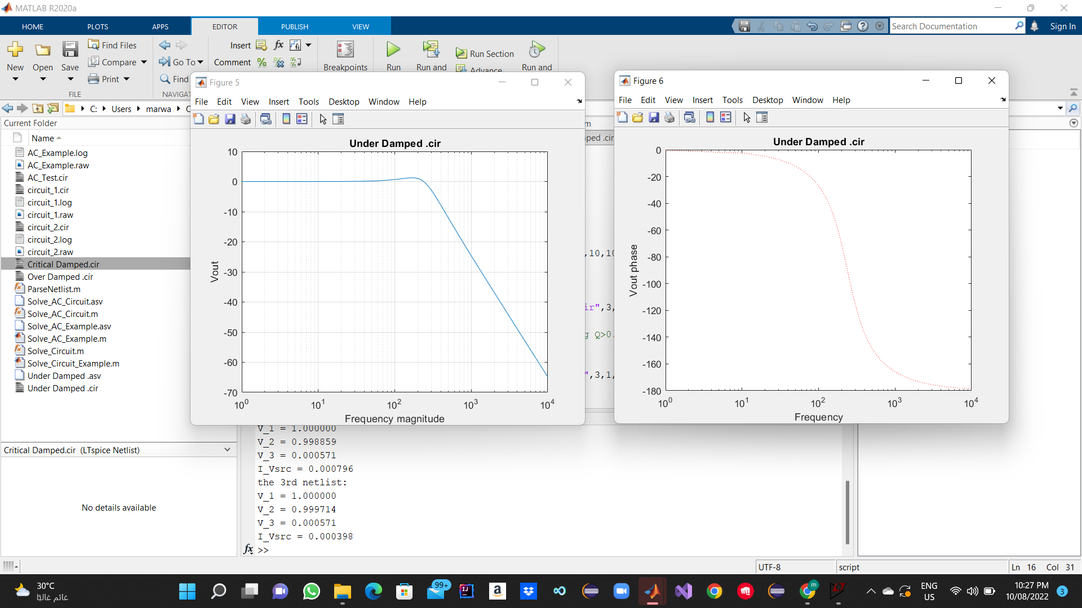

LTspice Results:

Critical Damping RLC:

Under Damped RLC:

Comment:

The Graphs Are The Same For Both Lt Spice and my Simulator

But LtSpice Is faster at getting Results and have more helping tools like cursor to have an accurate number for the cutoff Freq etc.

PART 3:

Added Support for both VCVS and VCCS :

Note:

Modified The Parseing function to add support for VCVS And VCCS

I used the modifeid one along with the original one ,its not optimum for coding it can be done with the orginal one with some modifications only.

My Simulator Results :

Non Inverting amplifier with UGF=10 Megahz connected in UGain Configuration

Lt SPice Results :

Comment: The Graphs are Identical The Simulator is spice accurate but its much slower than spice.